

|  |  |  |
| --- | --- | --- |
| **QUANTITATIVE SCIENCES DEPARTMENT** | |  |
| **Course:** **A2MAA** | |
| **Topic Title**: **Skills Test 1** | |
| Student Name:_____________________________________ | Date: __________2015 | | |
| Special Instructions: No calculator or notes | Time Allowed: 20 minutes | | |
|  | Marks: / 20 | | |

**Question 1 [4 marks]**

Construct a frequency table for the following scores.

77 80 76 75 80 75 76 80 78 78

**Question 2 [5 marks]**

Organise the data below into a grouped frequency distribution table using the

class intervals 50–59, 60–69, ...

|  |  |  |  |  |  |  |  |  |  |
| --- | --- | --- | --- | --- | --- | --- | --- | --- | --- |
| 79 | 81 | 84 | 84 | 60 | 87 | 51 | 59 | 82 | 59 |
| 58 | 62 | 81 | 65 | 52 | 60 | 85 | 68 | 88 | 82 |
| 73 | 65 | 88 | 70 | 80 | 83 | 51 | 52 | 50 | 69 |
| 76 | 51 | 53 | 75 | 56 | 89 | 88 | 58 | 76 | 67 |
| 74 | 59 | 77 | 54 | 65 | 76 | 54 | 73 | 67 | 70 |

**Question 3 [6 marks]**

Represent the following frequency table as a histogram.

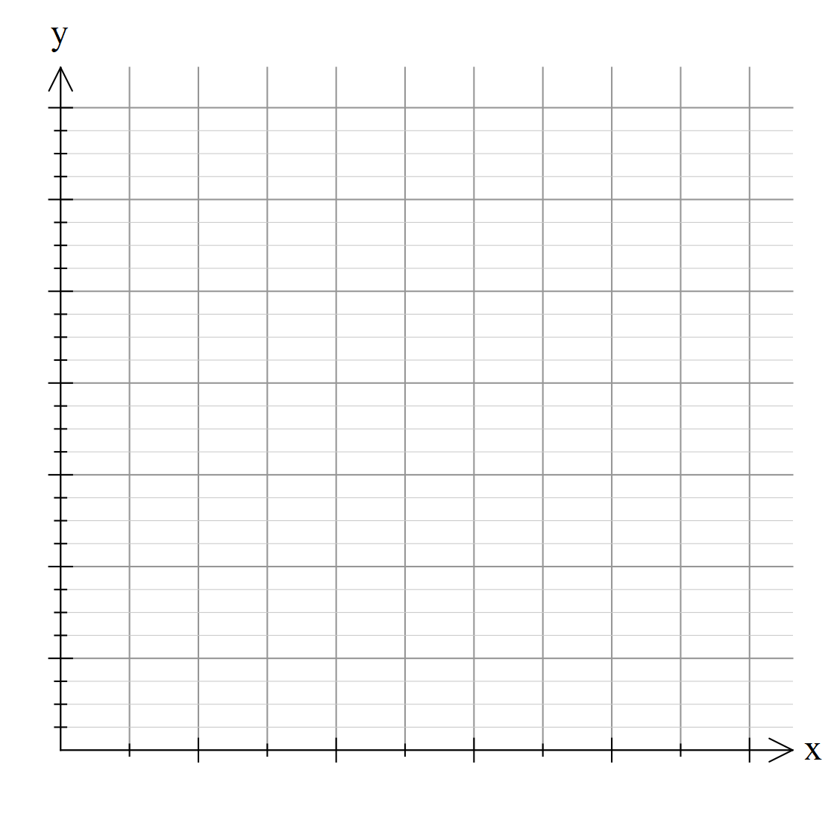

|  |  |
| --- | --- |
| **Score** | **Frequency** |
| 1 | 6 |
| 2 | 10 |
| 3 | 11 |  |
| 4 | 10 |
| 5 | 12 |
| 6 | 0 |
| 7 | 4 |
| 8 | 0 |
| 9 | 1 |

**Question 4 [6 marks]**

Consider the data below:

32, 51, 63, 17, 44, 65, 69, 68, 73, 8, 74, 72, 35, 63, 52, 26, 56, 72

Use the data to constuct a stem and leaf plot